
Job Vacancy

- education: Casual sports therapist

ACCRINGTON STANLEY COMMUNITY TRUST

REGISTERED CHARITY NO. 113957
- ABOUT US
Accrington Stanley Community Trust is the award-winning, official charity (number 1139575) of Accrington Stanley Football Club.
Accrington Stanley Community Trust was originally established under the banner of Football in the Community in 2007, with the aim to bring the professional club and their community closer together. After becoming a registered charity and re-forming as a Community Trust in 2010, the organisation has seen an accelerated rise and growth.
Accrington Stanley Community Trust has expanded at a phenomenal rate and work in 4 key themed areas: Sports Participation, Education, Health & Wellbeing and Community Engagement.
Football and in particular, Accrington Stanley Football Club has the ability to engage people, improve community cohesion and raise the hopes and aspirations of the people of Hyndburn. As a Club we are committed to ensuring that we respond to local needs whilst working strategically in line with regional and national agendas. We all recognise that sport can play a prominent role in addressing major issues such as obesity, anti-social behaviour, health, employment and attainment. Accrington Stanley Community Trust engages with over 16,000 people every year across 30 different projects.

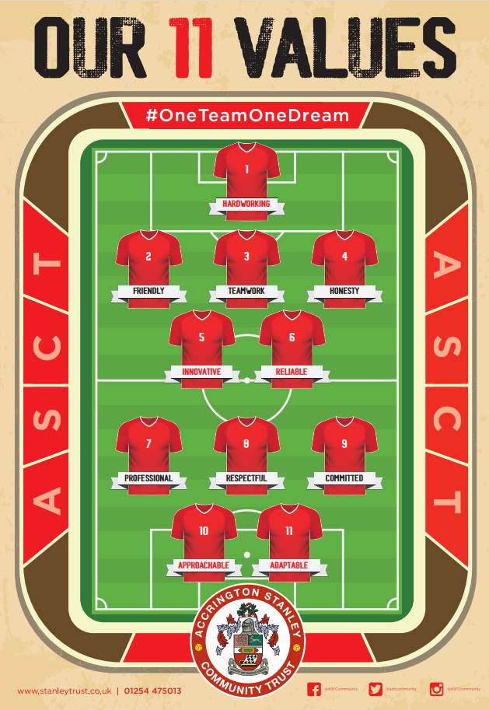
Vision
“Use the power of Accrington Stanley Football Club to improve the lives of the people of Hyndburn through participation in sport and exercise”.

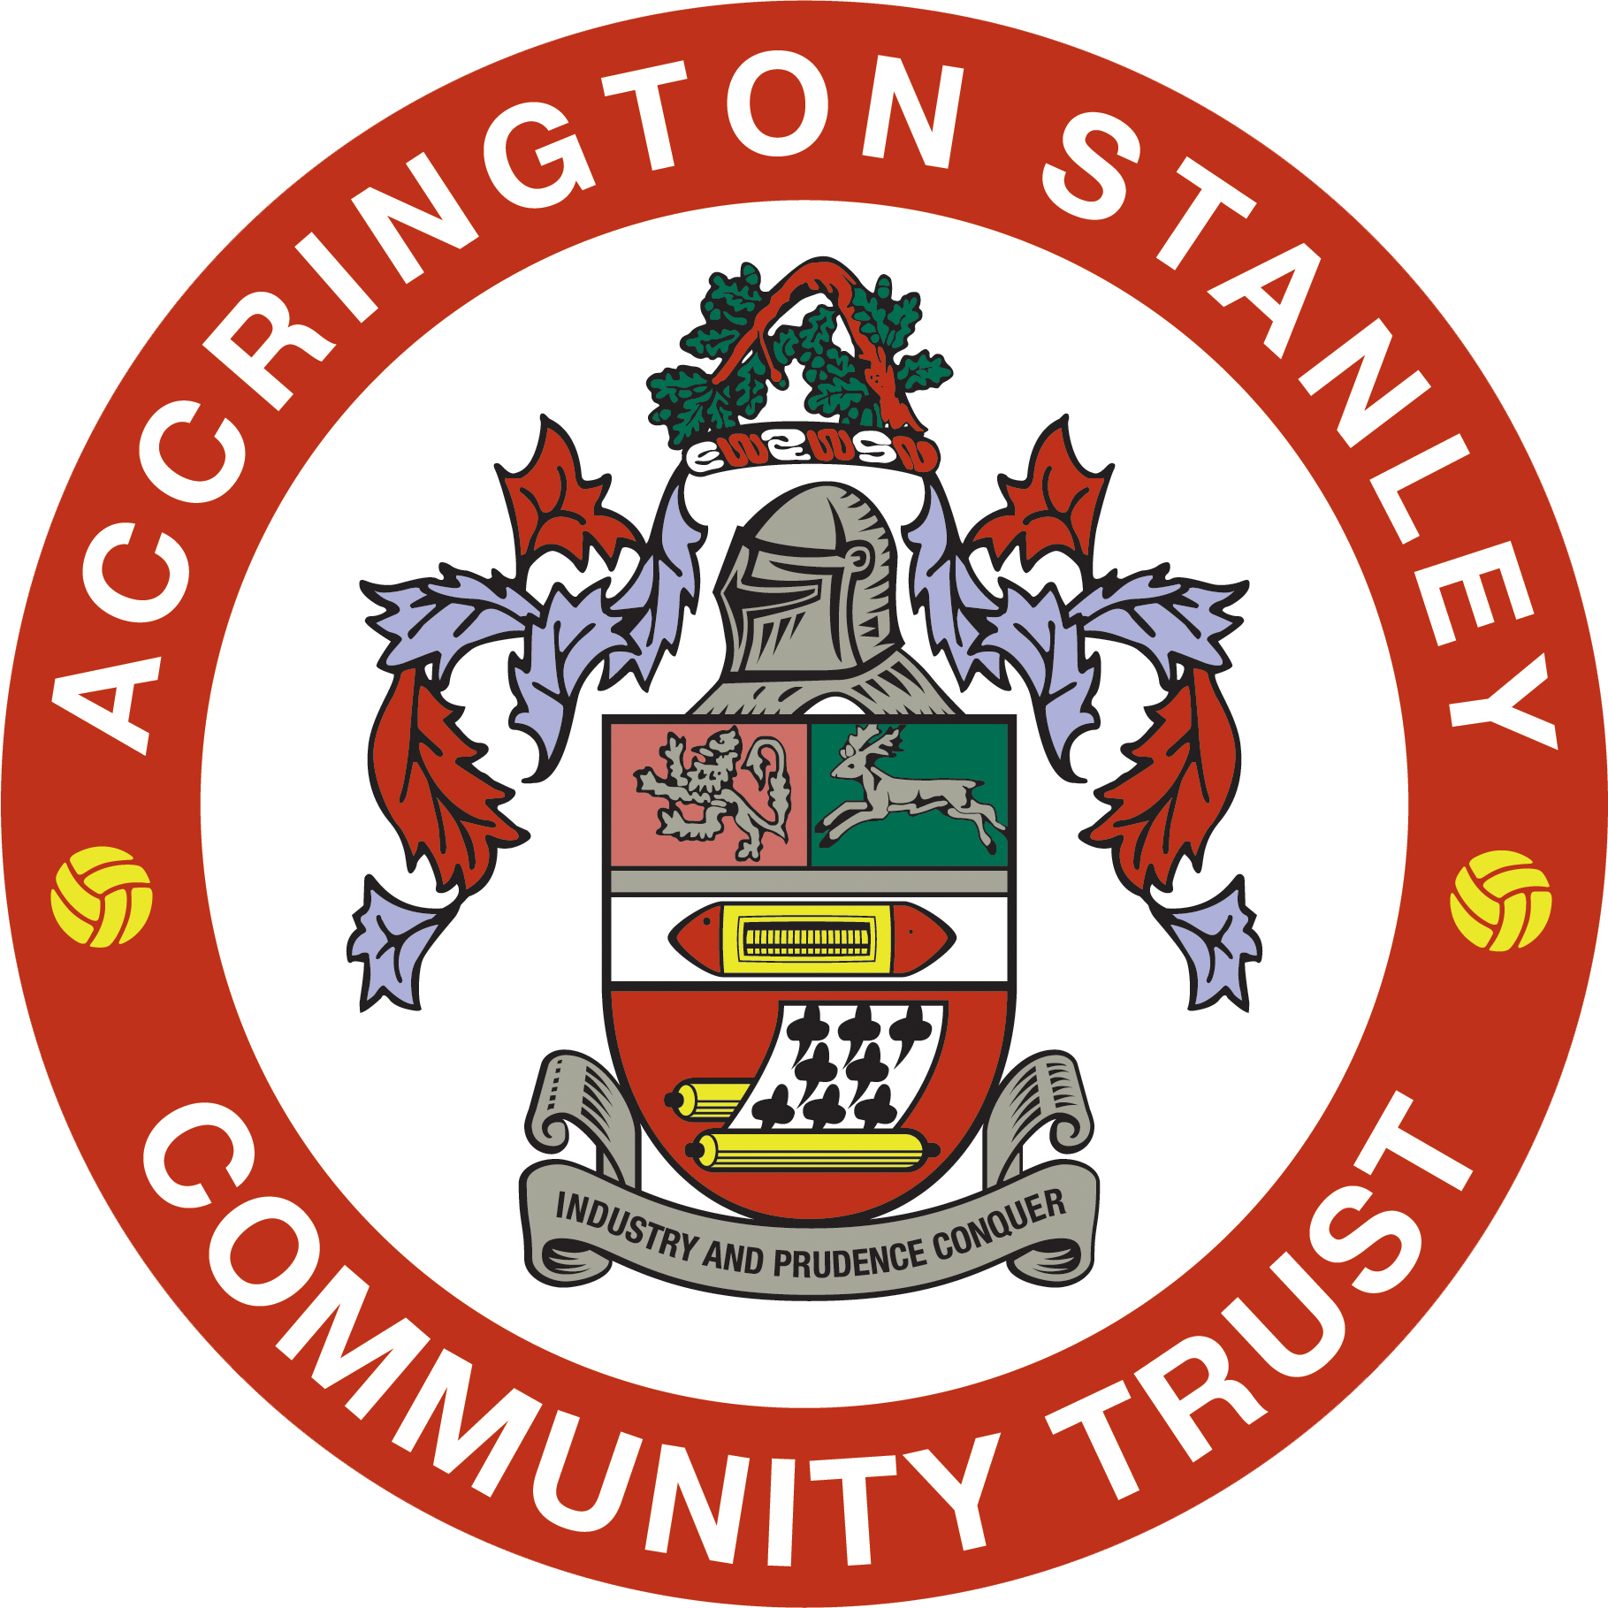

Mission
Our mission is to support the local community regardless of age, gender, race, religion or skill level and promote a healthier lifestyle through sport and education by encouraging individuals to take part in fun-based activities, which develop confidence, co-operation and education.


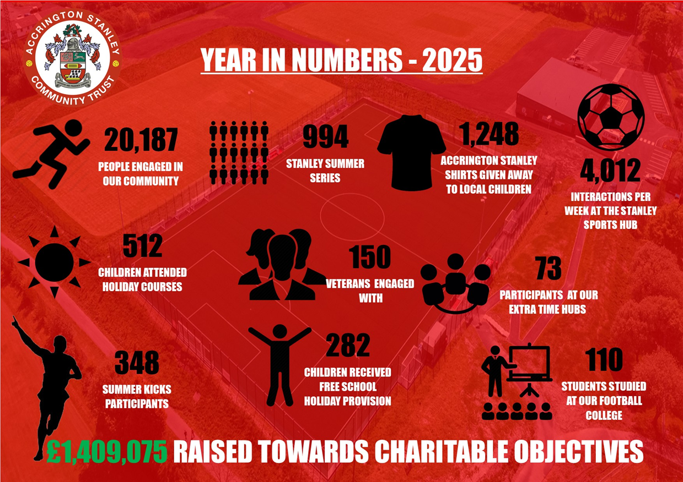

Work from Stanley Sports Hub
All of our employees are based at our state-of-the-art Stanley Sports Hub. The £4m community facility developed and operated by Accrington Stanley Community Trust provides a fantastic working environment. It’s also the training base for Accrington Stanley Football Club’s professional footballers and Academy players.
Stanley Sports Hub provides exceptional indoor and outdoor facilities including;
- Full size floodlit artificial football pitch.
- Small sided floodlit artificial football cage.
- Grass football pitches which can cater for various formats such as 5v5, 7v7, 9v9 and 11v11.
- Two cafeterias with refreshments available.
- Sports Hall
- Four training rooms which can accommodate up to 16 or 24 people.
- Two meeting rooms for up to 6 or 12 people.
- State of the art Gym
- Conference room with balcony for up to 24 people with stunning panoramic views.
- Four full size team changing rooms.
- Two officials changing rooms.
- Public toilet facilities inc disabled.
- Free onsite parking (up to 75 spaces) for users of the site.
- Accrington Stanley Community Trust offices.

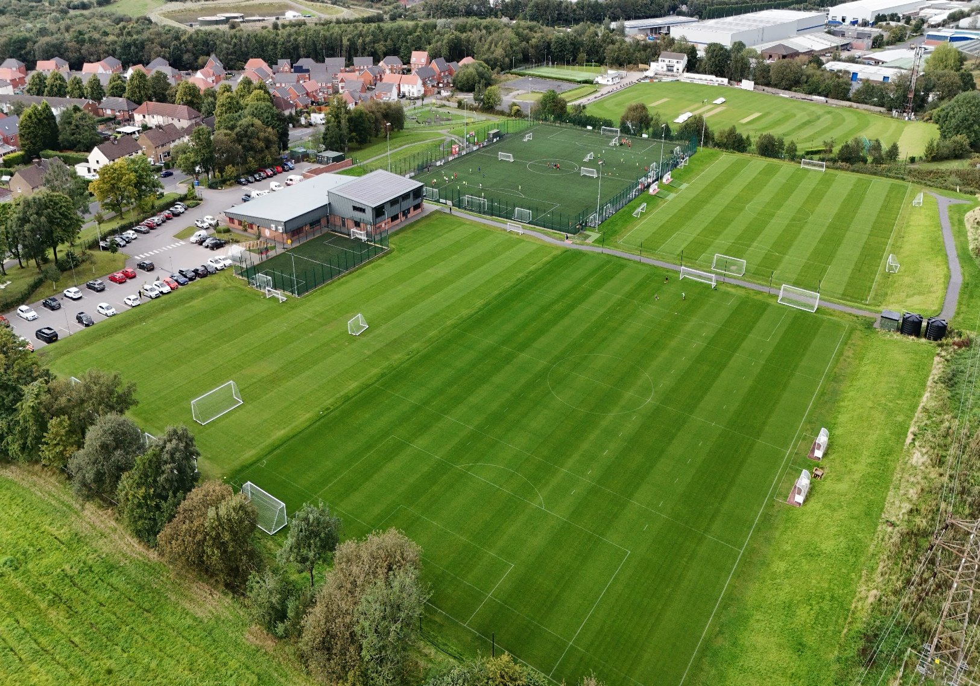

Job Title | Casual Sports Therapist/Physiotherapist
Reports to | Head of Education/Head of Youth Football
Location: | Stanley Sports Hub, Accrington
Contract: | Zero Hours Contract
Hours: | Variable
Remuneration: | Dependent on experience
Benefits: | - Free staff uniform  - Free ASFC home match day tickets  - Free gym use  - Free childcare scheme for school holidays
Annual Leave: | Included in remuneration
Closing Date: | Wednesday 8th July 2026 (interviews to take place week commencing 13th June 2026. Only successful candidates will be notified of interview)
Accrington Stanley Community Trust is seeking a motivated and enthusiastic Sessional Sports Therapist to support the health, wellbeing, and performance of our Youth Team players and Football College students. The successful candidate will provide pitch-side medical cover, injury assessment, treatment, rehabilitation, and player welfare support across training sessions, fixtures, and designated football education programmes.
The role is crucial in ensuring players receive high-quality medical and therapeutic support, helping them maximise participation, development, and performance within a safe and professional environment

All applications to stefan.wilson@stanleytrust.co.uk

The role fits in the organisation here:
Board of Trustees

Chief Executive Officer

Head of Education

Sports Tutor & Football Coach

Key facts & figures of the role: Key accountabilities
Injury Prevention and Player Care
- Conduct injury screening, musculoskeletal assessments, and movement analysis where appropriate.
- Deliver injury prevention programmes, warm-up protocols, and recovery strategies.
- Provide advice and education to players regarding injury prevention, rehabilitation, nutrition, hydration, and recovery.
Injury Assessment and Treatment
- Assess and diagnose sports-related injuries and determine appropriate treatment plans.
- Deliver hands-on treatment, including soft tissue therapy, taping, strapping, and other evidence-based interventions within scope of practice.
- Maintain accurate clinical records and treatment notes in line with professional standards and GDPR requirements.
- Refer players to external healthcare professionals when necessary.
Rehabilitation
- Design and implement individual rehabilitation programmes for injured players.
- Monitor rehabilitation progress and communicate return-to-play recommendations.
- Work collaboratively with coaches to facilitate safe and effective return-to-training and return-to-match participation.
Matchday and Training Support
- Provide pitch-side first aid and emergency care during training sessions and fixtures.
- Prepare and maintain medical equipment, first aid kits, and emergency action plans.
- Respond appropriately to medical emergencies in accordance with FA and governing body guidelines.
Communication and Collaboration
- Liaise regularly with coaching staff, parents/guardians (where appropriate), education staff, and external healthcare professionals.
- Attend staff meetings and player reviews as required.
- Contribute to a positive and supportive environment that promotes player welfare and development.
Safeguarding and Welfare
- Promote and safeguard the welfare of children, young people, and vulnerable adults.
- Adhere to Accrington Stanley Community Trust safeguarding policies and procedures at all times.
- Report any safeguarding concerns immediately through the appropriate channels.
General Responsibilities
- Represent Accrington Stanley Community Trust professionally at all times.
- Support the Trust's values, objectives, and community ethos.
- Undertake any other duties commensurate with the role as reasonably requested by management.

All applications to stefan.wilson@stanleytrust.co.uk

Key Relationships of the role: |  | Head of Education, Sport Tutors, Football College Coordinators & Head of Youth Football
What is needed to be successful in this role (Person Specification):
Core Competencies:
- Professional, reliable, and organised.
- Passionate about supporting young people in sport.
- Flexible approach to working hours.
- Strong problem-solving and decision-making skills.
- Commitment to continuous professional development.
- Ability to build and maintain trusted and effective relationships
Personal Qualities:
- Enthusiasm, energy and resilience
- Focused
- Personable
- Rational thinker
- Trustworthy
- Confident
Qualifications/ Experience:
Essential:
- BSc in Physiotherapy, Sports Therapy or Rehabilitation
- HCPC registration (Physiotherapists only)
- Membership of the Chartered Society of Physiotherapists or Society of Sports Therapists
Desirable:
- FA Safeguarding Certification (training can be provided)
- FA Intermediate Trauma and Medical Management in Football (ITMMiF)

Accrington Stanley Community Trust Vision:

“Use the power of Accrington Stanley Football Club to improve the lives of the people of Hyndburn through participation in sport and exercise”.

Mission:

Our mission is to support the local community regardless of age, gender, race, religion or skill level and promote a healthier lifestyle through sport and education by encouraging individuals to take part in fun based activities, which develop confidence, co-operation and education.

Core Values:
- Challenge behaviour and attitudes, promoting Respect and celebrating diversity
- Inspire to achieve and Fulfil potential
- Develop leaders, coaches and volunteers
- Innovate in delivery

Purpose:

In placing Accrington Stanley Football club at the heart of the community we will:
- Increase participation in Sport & Exercise and develop talent pathways.
- Promote wellbeing and healthy lifestyles within local communities.
- Deliver an inclusive programme of activities that involves and engages hard to reach groups, improving community cohesion.
- Develop and empower leaders, coaches and volunteers.
- Engage and inspire young people, raising and celebrating educational achievement.
- Govern the operations of ASCT efficiently and effectively.

Equality and Safeguarding:

ASCT are a charity committed to equality and the recruitment process for the role being advertised will adhere to the latest equality legislation.

ASCT is also committed to safeguarding and promoting the welfare of children and young people and expects all staff and employees to share this commitment. This role involves work with children and young people and is subject to Enhanced Disclosure and Barring Service (DBS) checks. Clearance through DBS system is required. As such this post is exempt for the Rehabilitation of Offenders Act (1974) and the applicant must disclose all previous convictions including spent convictions. Two references will also be required. Applicants will, in addition be expected to undertake training appropriate to the role.

You may be expected to conduct yourself in other ways and undertake different duties which are reasonable in the opinion of the Trust. Your job profile is not limited and may be reasonably modified as necessary to meet the needs of the organisation.

Manager Sign Off: Date:

Employee Sign Off: Date:

