
Job Vacancy

- SPORTS TUTOR & FOOTBALL COACH

ACCRINGTON STANLEY COMMUNITY TRUST
REGISTERED CHARITY NO. 113957
- ABOUT US
Accrington Stanley Community Trust is the award-winning, official charity (number 1139575) of Accrington Stanley Football Club.
Accrington Stanley Community Trust was originally established under the banner of Football in the Community in 2007, with the aim to bring the professional club and their community closer together. After becoming a registered charity and re-forming as a Community Trust in 2010, the organisation has seen an accelerated rise and growth.
Accrington Stanley Community Trust has expanded at a phenomenal rate and work in 4 key themed areas: Sports Participation, Education, Health & Wellbeing and Community Engagement.
Football and in particular, Accrington Stanley Football Club has the ability to engage people, improve community cohesion and raise the hopes and aspirations of the people of Hyndburn. As a Club we are committed to ensuring that we respond to local needs whilst working strategically in line with regional and national agendas. We all recognise that sport can play a prominent role in addressing major issues such as obesity, anti-social behaviour, health, employment and attainment. Accrington Stanley Community Trust engages with over 16,000 people every year across 30 different projects.

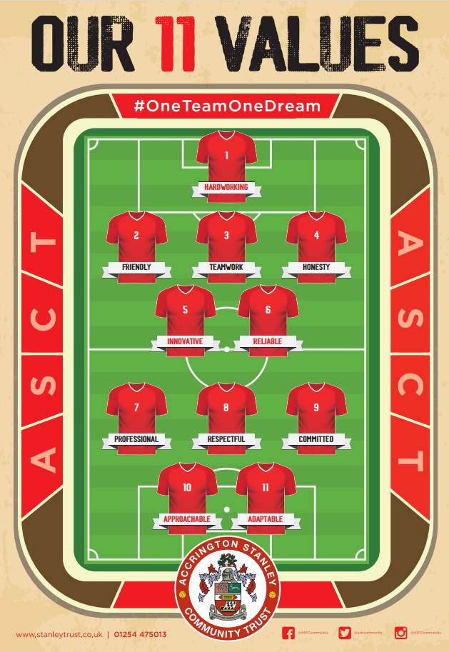
Vision
“Use the power of Accrington Stanley Football Club to improve the lives of the people of Hyndburn through participation in sport and exercise”.

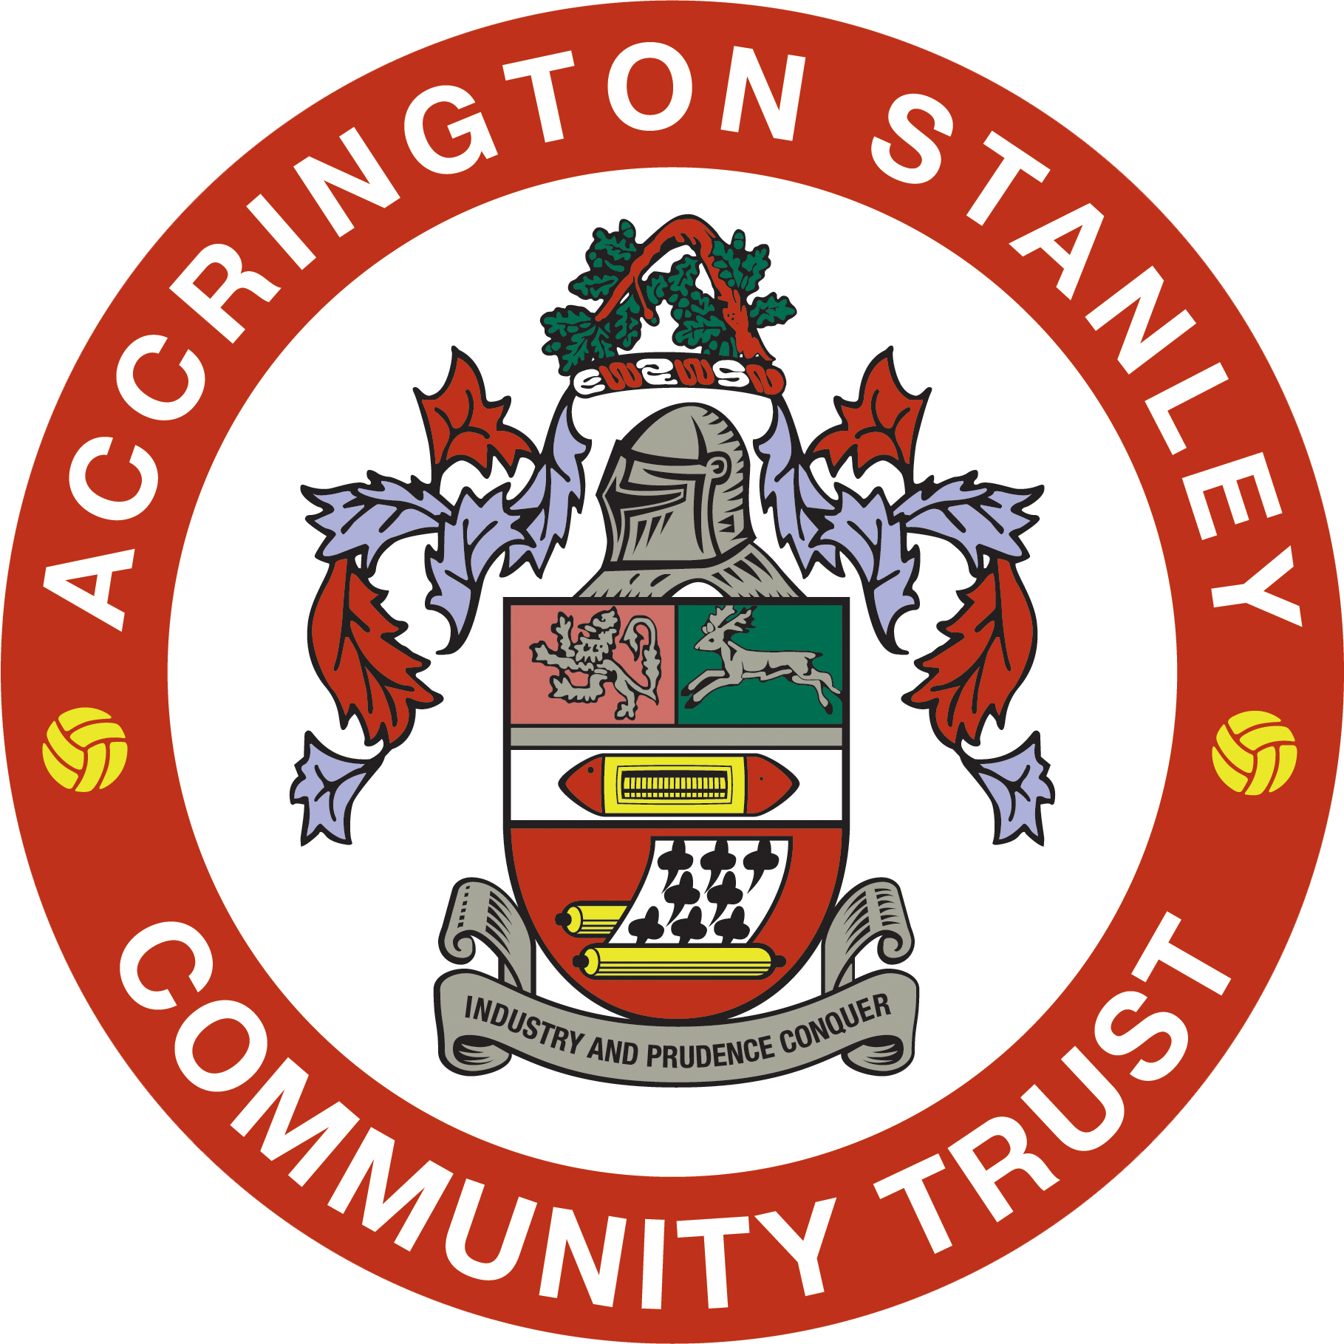

Mission
Our mission is to support the local community regardless of age, gender, race, religion or skill level and promote a healthier lifestyle through sport and education by encouraging individuals to take part in fun-based activities, which develop confidence, co-operation and education.


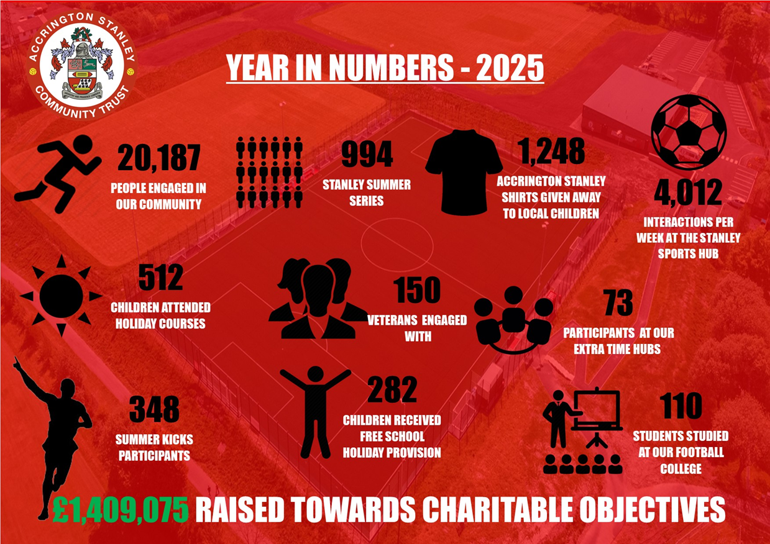

Work from Stanley Sports Hub
All of our employees are based at our state-of-the-art Stanley Sports Hub. The £4m community facility developed and operated by Accrington Stanley Community Trust provides a fantastic working environment. It’s also the training base for Accrington Stanley Football Club’s professional footballers and Academy players.
Stanley Sports Hub provides exceptional indoor and outdoor facilities including;
- Full size floodlit artificial football pitch.
- Small sided floodlit artificial football cage.
- Grass football pitches which can cater for various formats such as 5v5, 7v7, 9v9 and 11v11.
- Two cafeterias with refreshments available.
- Sports Hall
- Four training rooms which can accommodate up to 16 or 24 people.
- Two meeting rooms for up to 6 or 12 people.
- State of the art Gym
- Conference room with balcony for up to 24 people with stunning panoramic views.
- Four full size team changing rooms.
- Two officials changing rooms.
- Public toilet facilities inc disabled.
- Free onsite parking (up to 75 spaces) for users of the site.
- Accrington Stanley Community Trust offices.

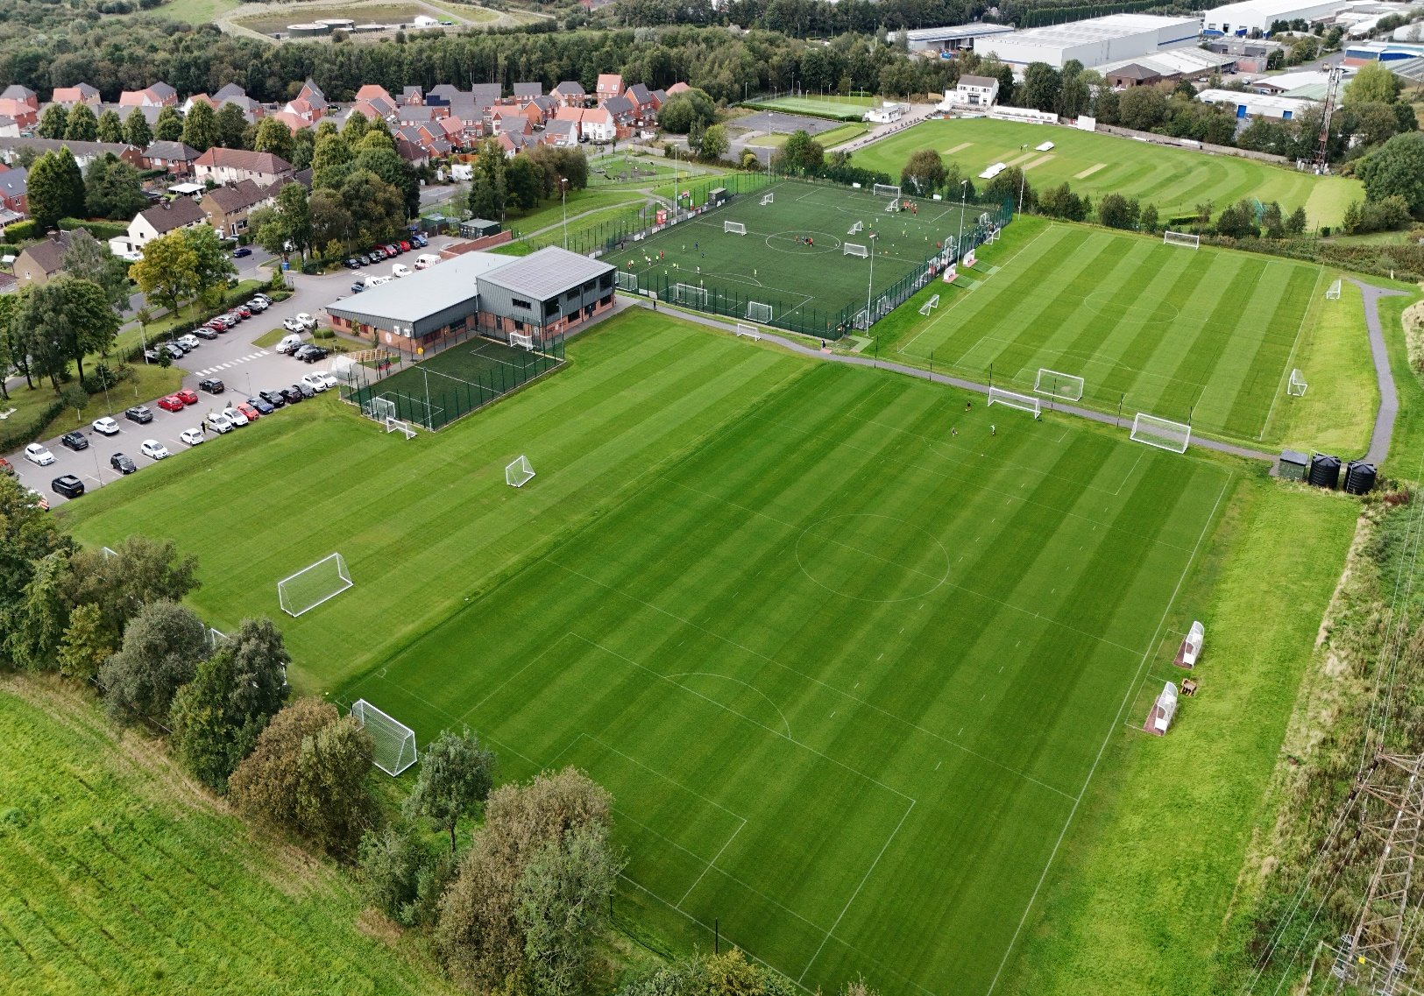

Job Title | Sports Tutor & Football Coach
Reports to | Head of Education
Location: | Stanley Sports Hub, Accrington
Contract: | Full Time - Permanent
Hours: | 37.5 Hours Per Week
Remuneration: | £25,000-£28,000 (Plus bonuses, pension scheme, expenses)
Benefits: | - Free on-site parking;  - Free use of Stanley Sports Hub gym facilities, subject to applicable rules and availability;  - Access to Trust vehicles for authorised business use;  - Training, professional development and workforce development opportunities;  - Trust uniform and branded clothing, where applicable to the role;  - Health and wellbeing support schemes operated by the Trust from time to time;  - Employee recognition, reward and appreciation schemes;  - Opportunities to represent the Trust at regional, national or international events, projects,  - conferences or exchange visits where appropriate;  - Access to Trust childcare provision, holiday activities or family support initiatives, subject to eligibility and availability.
Annual Leave: | 25 days annual leave plus bank holidays on commencement;  29 days annual leave plus bank holidays after 5 years’ continuous service;  33 days annual leave plus bank holidays after 10 years’ continuous service.
Closing Date: | Wednesday 8th July 2026 (interviews to take place week commencing 13th July 2026. Only successful candidates will be notified of interview
Under the reasonable direction of the Head of Education, the successful candidate will carry out the professional duties of a Further Education Sports Tutor and with the hours split approximately 50/50 across the 2 roles. Accrington Stanley Community Trust place an emphasis on developing the individual both academically and as a person, and would expect the post-holder to contribute towards this ethos.

Sports Tutor:
The successful candidate will provide quality teaching across our education provision, meeting pre-set objectives and learning outcomes which are stipulated in the funding requirements. Facilitating and encouraging a learning experience which provides students with the opportunity to achieve their individual potential is important to the team, and all staff are responsible for contributing to raising standards and aspirations of students. The role is estimated to include around 12 hours of teaching.

Staff within our Education department are required to implement and deliver an appropriately broad, balanced, relevant and differentiated curriculum for students which will encourage a learning experience that provides students with the opportunity to achieve their individual potential.

Football Coach:

Practical Delivery – Leading, organising and delivering on all practical aspects of the Football Education Programme. A key area of the role will be to create and implement a successful, engaging training and games programme for all of our students, as well as being the lead coach for a squad on matchday days. Duties will also include keeping up to date with the relevant administration duties.

All applications to stefan.wilson@stanleytrust.co.uk

The role fits in the organisation here:
Board of Trustees

Chief Executive Officer

Head of Education

Sports Tutor & Football Coach

Key facts & figures of the role: Key accountabilities
Sports Tutor:
- To enthuse, engage and motivate students on a daily basis
- To undertake a part role in the planning, delivery and assessment of our sport-based qualifications included within our Education provision
- To maintain good order and discipline among the students and safeguard their health and safety both when they are on the Trust premises and when they are engaged in authorised Trust activities elsewhere
- Monitor and maintain appropriate records/data related to target grades, attainment, achievement and attendance.
- Contribute positively to the education departments’ aims and objectives, displaying an exceptional level of team work and collaborative skills
Football Coach:
- To deliver on the practical element of the Football College Programme
- To develop and engaging and successful season long training and games programme for students on programme.
- To be the head coach of a team on match days, and transport the squad via minibus.
- To ensure match days are organised effectively for all the squad. This includes allocating students to the squad on a weekly basis, organising the necessary kit/equipment and liasing with parents to ensure everybody attends.
- To assist with the recruitment of future students onto the Football College Programme.
- To support the Education Department on any new or existing projects when required.
- Actively support the aims and objectives of ASCT in all activities.
- Undertake other duties as required by the charity from time to time.

All applications to stefan.wilson@stanleytrust.co.uk
Key Relationships of the role: |  | Head of Education, Sport Tutors, Lead Coach and Recruitment Officer, Employability Officer
What is needed to be successful in this role (Person Specification):
Core Competencies:
- Excellent communicator (written, verbal and listening)
- Effective time management/organisational skills
- Strong work ethic and reliability
- Ability to use own initiative
- Team player
- Strong influencing and mentoring skills
- Ability to build and maintain trusted and effective relationships
- Adaptability and flexibility with day to day tasks and workloads
Personal Qualities:
- Enthusiasm, energy and resilience
- Focused
- Personable
- Rational thinker
- Trustworthy
- Confident
- Competitive
- Desire to lead, inspire and motivate
Qualifications/ Experience:
Essential:
- Degree in Sport or Physical Education
- A recognised teaching qualification (Level 5 or above)
- Minimum UEFA C/Level 2 in Football Coaching
- In date child protection certificate (or willingness to update ASAP).
- Full UK Driving Licence – Car owner and willingness to use for work.
- The ability to form and maintain positive and professional relationships with 16-19 year olds students
- Ability to accurately assess and mark students work against set criteria within a given time frame
- Expect and uphold the highest standards in order to inspire students to work at target grade or higher
Desirable
- A knowledge and understanding of the NCFE Level 2 and BTEC Level 3 in Sport (RQF) specification
- Experience coaching footballers aged 16 and over
- Teaching experience in a further education setting
- Innovative and flexible approach to supporting students

Accrington Stanley Community Trust Vision:

“Use the power of Accrington Stanley Football Club to improve the lives of the people of Hyndburn through participation in sport and exercise”.

Mission:

Our mission is to support the local community regardless of age, gender, race, religion or skill level and promote a healthier lifestyle through sport and education by encouraging individuals to take part in fun based activities, which develop confidence, co-operation and education.

Core Values:
- Challenge behaviour and attitudes, promoting Respect and celebrating diversity
- Inspire to achieve and Fulfil potential
- Develop leaders, coaches and volunteers
- Innovate in delivery

Purpose:

In placing Accrington Stanley Football club at the heart of the community we will:
- Increase participation in Sport & Exercise and develop talent pathways.
- Promote wellbeing and healthy lifestyles within local communities.
- Deliver an inclusive programme of activities that involves and engages hard to reach groups, improving community cohesion.
- Develop and empower leaders, coaches and volunteers.
- Engage and inspire young people, raising and celebrating educational achievement.
- Govern the operations of ASCT efficiently and effectively.

Equality and Safeguarding:

ASCT are a charity committed to equality and the recruitment process for the role being advertised will adhere to the latest equality legislation.

ASCT is also committed to safeguarding and promoting the welfare of children and young people and expects all staff and employees to share this commitment. This role involves work with children and young people and is subject to Enhanced Disclosure and Barring Service (DBS) checks. Clearance through DBS system is required. As such this post is exempt for the Rehabilitation of Offenders Act (1974) and the applicant must disclose all previous convictions including spent convictions. Two references will also be required. Applicants will, in addition be expected to undertake training appropriate to the role.

You may be expected to conduct yourself in other ways and undertake different duties which are reasonable in the opinion of the Trust. Your job profile is not limited and may be reasonably modified as necessary to meet the needs of the organisation.

Manager Sign Off: Date:

Employee Sign Off: Date:

