
Job Vacancy

- Sports Hub Attendant

ACCRINGTON STANLEY COMMUNITY TRUST
REGISTERED CHARITY NO. 1139575

- ABOUT US
Accrington Stanley Community Trust is the award-winning, official charity (number 1139575) of Accrington Stanley Football Club.
Accrington Stanley Community Trust was originally established under the banner of Football in the Community in 2007, with the aim to bring the professional club and their community closer together. After becoming a registered charity and re-forming as a Community Trust in 2010, the organisation has seen an accelerated rise and growth.
Accrington Stanley Community Trust has expanded at a phenomenal rate and work in 4 key themed areas: Sports Participation, Education, Health & Wellbeing and Community Engagement.
Football and in particular, Accrington Stanley Football Club has the ability to engage people, improve community cohesion and raise the hopes and aspirations of the people of Hyndburn. As a Club we are committed to ensuring that we respond to local needs whilst working strategically in line with regional and national agendas. We all recognise that sport can play a prominent role in addressing major issues such as obesity, anti-social behaviour, health, employment and attainment.
Accrington Stanley Community Trust engages with over 16,000 people every year across 30 different projects.

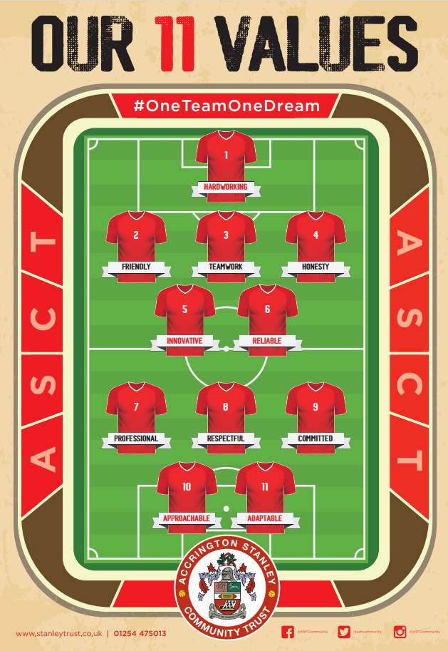
Vision
“Use the power of Accrington Stanley Football Club to improve the lives of the people of Hyndburn through participation in sport and exercise”.

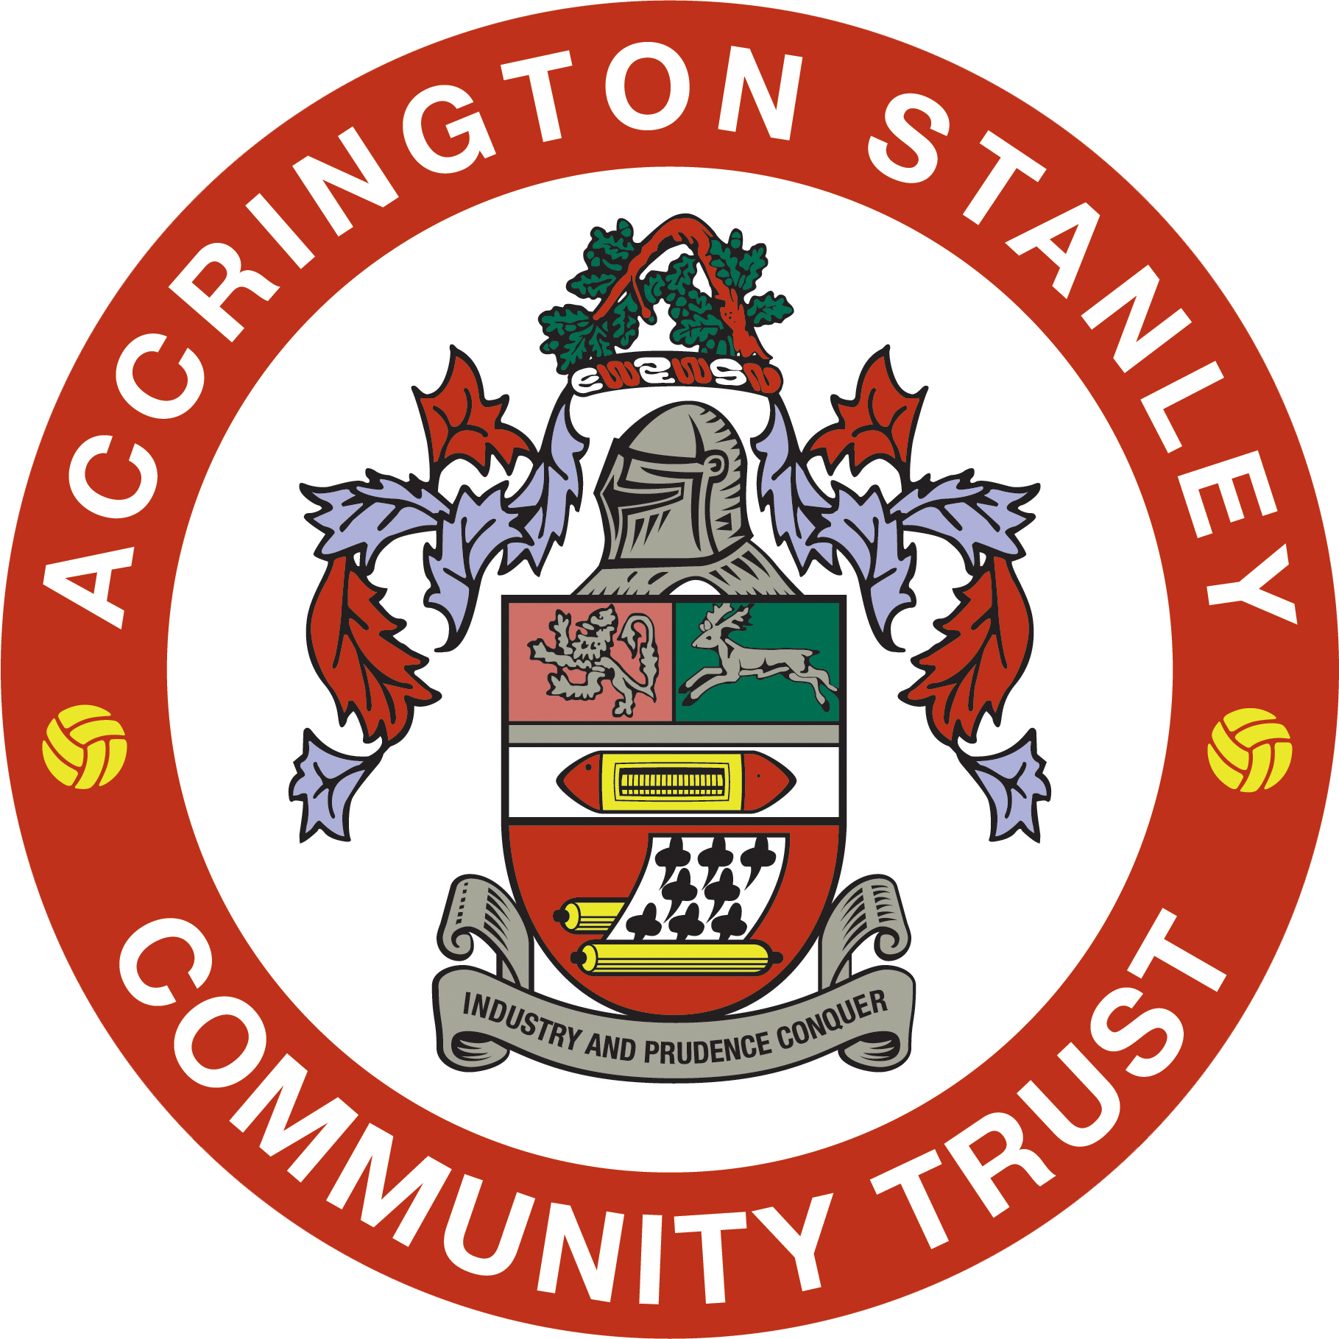

Mission
Our mission is to support the local community regardless of age, gender, race, religion or skill level and promote a healthier lifestyle through sport and education by encouraging individuals to take part in fun-based activities, which develop confidence, co-operation and education.
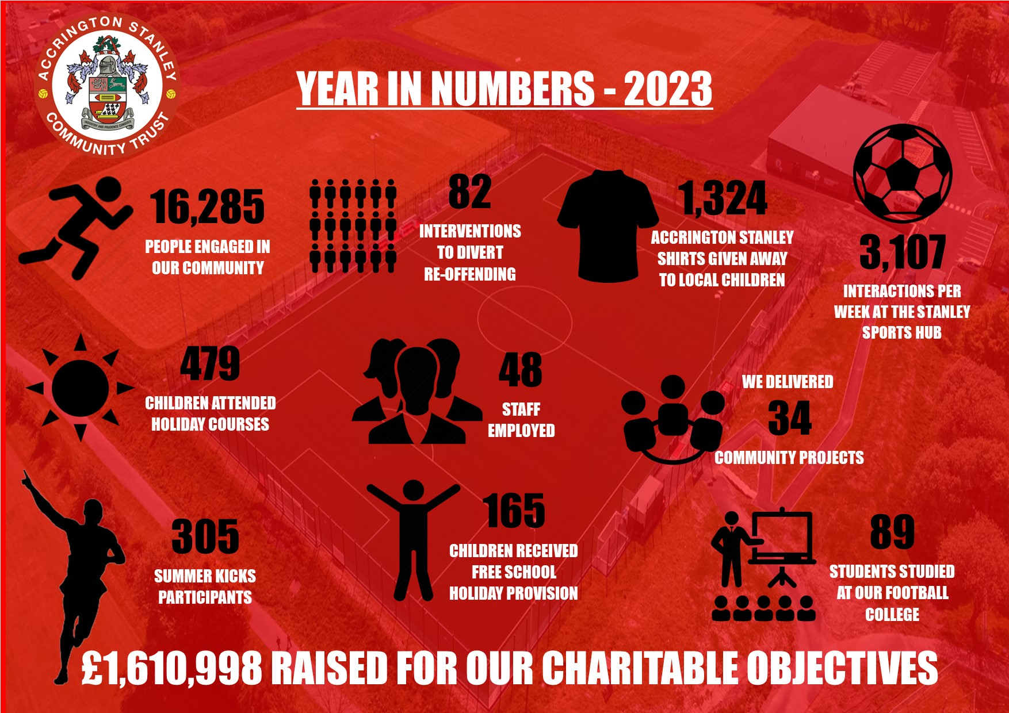



Work from Stanley Sports Hub
All of our employees and workers are based at our state-of-the-art Stanley Sports Hub. The £4m community facility developed and operated by Accrington Stanley Community Trust provides a fantastic working environment. It’s also the training base for Accrington Stanley Football Club’s professional footballers and Academy players.
Stanley Sports Hub provides exceptional indoor and outdoor facilities including;
- Full size floodlit artificial football pitch.
- Small sided floodlit artificial football cage.
- Grass football pitches which can cater for various formats such as 5v5, 7v7, 9v9 and 11v11.
- Two cafeterias with refreshments available.
- Sports Hall
- Four training rooms which can accommodate up to 16 or 24 people.
- Two meeting rooms for up to 6 or 12 people.
- State of the art Gym
- Conference room with balcony for up to 24 people with stunning panoramic views.
- Four full size team changing rooms.
- Two officials changing rooms.
- Public toilet facilities inc disabled.
- Free onsite parking (up to 75 spaces) for users of the site.
- Accrington Stanley Community Trust offices.

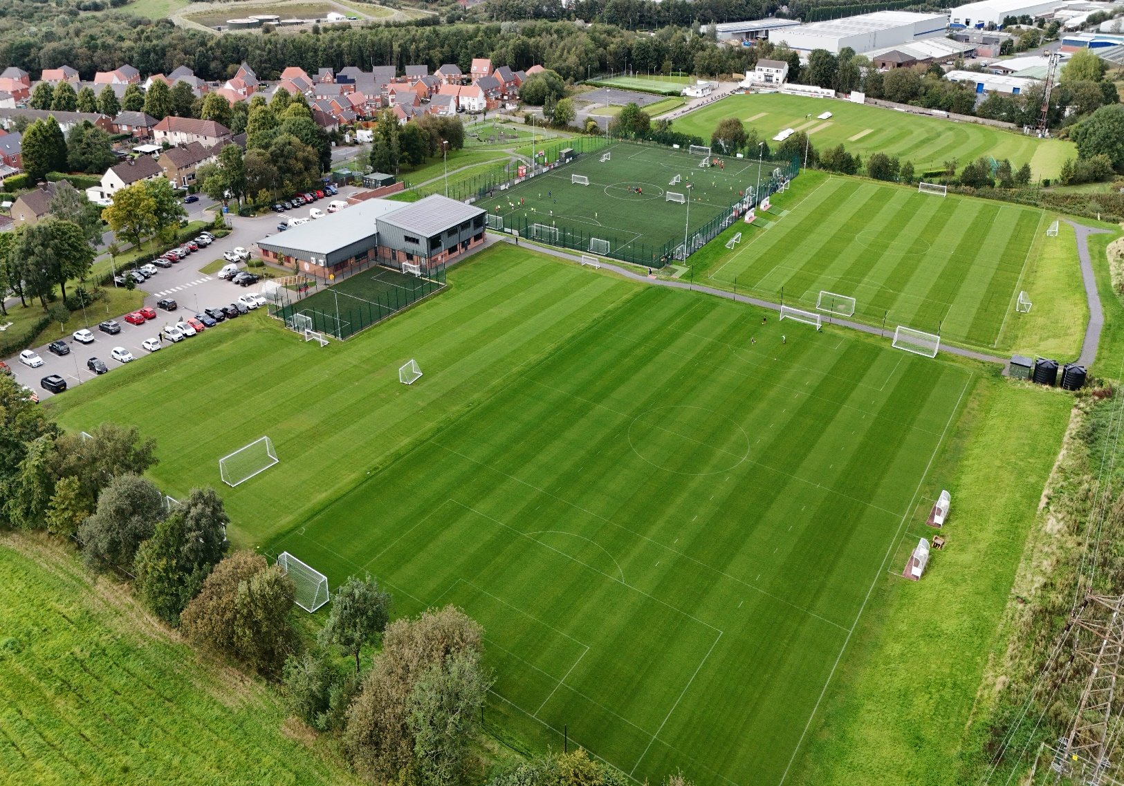

Job Title |  | Sports Hub Attendant
Reports to |  | Facility and Administration Manager
Location: |  | Stanley Sports Hub, Thorneyholme Road, Accrington, BB5 6BD
Contract: |  | Zero-Hours Contract
Hours: |  | Evenings and Weekends - Variable Hours
Remuneration: |  | Up to £12.87 (including 12.5% holiday pay).
Additional Benefits: |  | On site Free Gym Facility.
Closing Date: |  | Ongoing
The Purpose of the role:
Accrington Stanley Community Trust require Sports Hub Attendants to coordinate evening and weekend bookings, serve refreshments and help with the cleanliness of the £4m Stanley Sports Hub facility.

There is a requirement that all candidates have good customer service skills and can create a friendly environment for other staff and customers.

The successful candidates will provide supervision to all areas of the facilities (internal and external) thereby ensuring the safety and enjoyment of customers and participants.

The successful candidates will need to be available to work evenings and weekends (operating hours: 16:45-22:15, Monday-Friday, 08:15-17:15 Saturday-Sunday) when required.

Rotas are issued on a monthly basis to workers. There will also be a supervisor on each shift, with responsibility for supervising all workers and ensuring all jobs are completed to the required standard.

The role fits in the organisation here:
CEO

Facility and Admin Manager

Sports Hub Supervisor

Sports Hub Attendant

Key responsibilities:
This is not a comprehensive list of all the tasks which may be required of the post holder. It is illustrative of the general nature and level of responsibility of the work to be undertaken;
- To work under the direction of the Sports Hub Supervisor on each shift.
- To assist, advise and supervise users in all areas of the of the facilities.
- Cleaning of all areas being used by participants and customers within the facilities.
- To assist and set up sports equipment and pitches as determined by the bookings.
- To ensure that the public comply with the rules and regulations applicable within and to the various facilities.
- To ensure compliance with the various regulations relating to the control of hazardous cleaning substances.
- To interchange with and support other Accrington Stanley Community Trust employees and workers in accordance with personal ability, in the execution of their duties.
- To set up, attend and supervise any special events, which may be organised.
- To undertake any duties of the post, which require contact with, or provision of service to the customers in a courteous helpful and professional manner in line with the Trust’s customer care policy.
- Prepare and serve high quality refreshments to customers from the kitchen and/or snack hut.
- Keep both the kitchen and snack hut clean, stocked up and tidy ready for the next shift.
- Ensure cleaning schedules are adhered to at all times including a regular deep clean.
- Maintain accurate written daily/weekly checks in accordance with health and safety and food hygiene procedures.
- Maintain a clear, well organised and easy to use counter and storage areas.
- Ability to use the till system and follow monetary procedures.
- Any other duties, which may from time to time, be requested.

In addition to the main duties and responsibilities identified for this post, every worker has a number of general responsibilities:

- To wear the uniform provided and keep a good level of personal hygiene.
- Adopt a high standard of customer care at all times. If a customer requires assistance, even if this does not directly relate to your job, make every effort to help or find someone who can.
- Help to keep the facilities well maintained by picking up litter and emptying bins when you are in public areas.
- Report any faulty equipment or damage to the supervisor.
Key Relationships of the role: |  |  | Facility and Administration Manager, Catering Manager, Sports Hub Supervisor.
What is needed to be successful in this role (Person Specification):
Core Competencies:
- Good communicator (verbal and listening)
- Effective time management/organisational skills
- Strong work ethic and reliability
- Ability to use own initiative
- Team player
- Ability to build and maintain trusted and effective relationships
- Adaptability and flexibility with day-to-day tasks and workloads
Personal Qualities:
- Enthusiasm, energy and resilience
- Focused
- Personable
- Rational thinker
- Trustworthy
- Confident
Qualifications/ Experience:
Essential
- Worked in a similar role i.e. café, sports, leisure, cleaning
- Good level of customer service and can interact with people in a friendly manner.
- To be in reasonable physical condition to be able to move equipment such as goalposts and empty bins, cleaning of areas etc.

Equality and Safeguarding:

ASCT are a charity committed to equality and the recruitment process for the role being advertised will adhere to the latest equality legislation.

ASCT is also committed to safeguarding and promoting the welfare of children and young people and expects all staff and employees to share this commitment. This role involves work with children and young people and is subject to Enhanced Disclosure and Barring Service (DBS) checks. Clearance through DBS system is required. As such this post is exempt for the Rehabilitation of Offenders Act (1974) and the applicant must disclose all previous convictions including spent convictions. Two references will also be required. Applicants will, in addition be expected to undertake training appropriate to the role.
Manager Sign Off: |  |  |  | Date:
Worker Sign Off: |  |  |  | Date:

You may be expected to conduct yourself in other ways and undertake different duties which are reasonable in the opinion of the Trust. Your job profile is not limited and may be reasonably modified as necessary to meet the needs of the organisation.

How to Apply:

Please send your CV along with a cover letter outlining your suitability to the role to jobs@stanleytrust.co.uk

Interviews will take place TBC.

